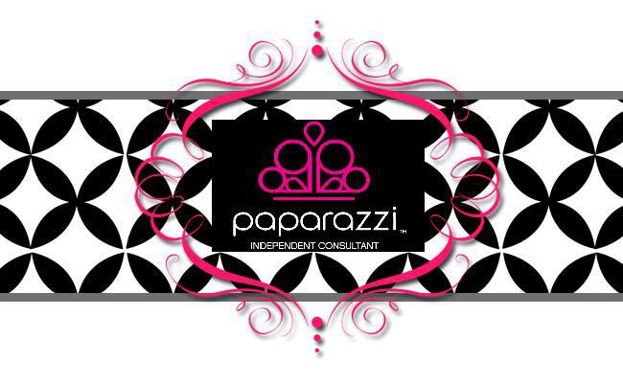

Paparazzi Accessories offers beautiful $5 jewelry. We do home parties and you get free jewelry when you host a party. I'm also looking for new consultants to sell jewelry. You make 45% commission, plus commission when you have a team of your own consultants. It is very easy to do, the jewelry is beautiful and everything is $5 or less. It is a great opportunity to have your own business. Refer a friend for free jewelry too!

I would love to share this opportunity with you or schedule a party with you today.

Sheila Smith • 919-427-1641
http://www.paparazziaccessories.com/11637

Paparazzi Accessories offers beautiful $5 jewelry. We do home parties and you get free jewelry when you host a party. I'm also looking for new consultants to sell jewelry. You make 45% commission, plus commission when you have a team of your own consultants. It is very easy to do, the jewelry is beautiful and everything is $5 or less. It is a great opportunity to have your own business. Refer a friend for free jewelry too!

I would love to share this opportunity with you or schedule a party with you today.

Sheila Smith • 919-427-1641
http://www.paparazziaccessories.com/11637

Paparazzi Accessories offers beautiful $5 jewelry. We do home parties and you get free jewelry when you host a party. I'm also looking for new consultants to sell jewelry. You make 45% commission, plus commission when you have a team of your own consultants. It is very easy to do, the jewelry is beautiful and everything is $5 or less. It is a great opportunity to have your own business. Refer a friend for free jewelry too!

I would love to share this opportunity with you or schedule a party with you today.

Sheila Smith • 919-427-1641
http://www.paparazziaccessories.com/11637

Paparazzi Accessories offers beautiful $5 jewelry. We do home parties and you get free jewelry when you host a party. I'm also looking for new consultants to sell jewelry. You make 45% commission, plus commission when you have a team of your own consultants. It is very easy to do, the jewelry is beautiful and everything is $5 or less. It is a great opportunity to have your own business. Refer a friend for free jewelry too!

I would love to share this opportunity with you or schedule a party with you today.

Sheila Smith • 919-427-1641
http://www.paparazziaccessories.com/11637

