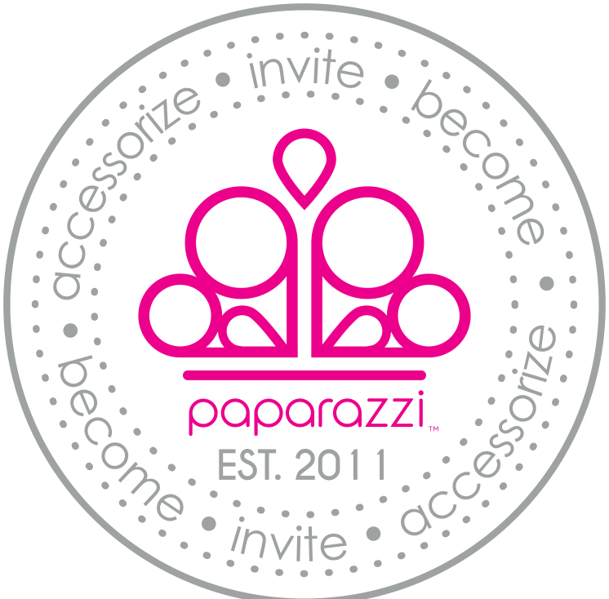 Win a Free Shopping Spree!!!
Name: ____________________________________________________________________
E-mail: ____________________________________________________________________
Phone: __________________________________________ City:_____________________
Want to host a home jewelry party? YES MAYBE NO
Want to host a basket/work party? YES MAYBE NO
Want to host a Facebook party? YES MAYBE NO
Want Paparazzi as a fundraiser? YES MAYBE NO
Want info on how to make money selling Paparazzi? YES NO
Want to buy more in the future or get a newsletter? YES NO
Win a Free Shopping Spree!!!
Name: __________________________________________________________________________
E-mail: _________________________________________________________________________
Phone: _____________________________________________ City:_______________________
Want to host a home jewelry party? YES MAYBE NO
Want to host a basket/work party? YES MAYBE NO
Want to host a Facebook party? YES MAYBE NO
Want Paparazzi as a fundraiser? YES MAYBE NO
Want info on how to make money selling Paparazzi? YES NO
Want to buy more in the future or get a newsletter? YES NO
Win a Free Shopping Spree!!!
Name: ______________________________________________________________________
E-mail: ______________________________________________________________________
Phone: _____________________________________________ City:_____________________
Want to host a home jewelry party? YES MAYBE NO
Want to host a basket/work party? YES MAYBE NO
Want to host a Facebook party? YES MAYBE NO
Want Paparazzi as a fundraiser? YES MAYBE NO
Want info on how to make money selling Paparazzi? YES NO
Want to buy more in the future or get a newsletter? YES NO
Win a Free Shopping Spree!!!
Name: __________________________________________________________________________
E-mail: __________________________________________________________________________
Phone: __________________________________________ City:__________________________
Want to host a home jewelry party? YES MAYBE NO
Want to host a basket/work party? YES MAYBE NO
Want to host a Facebook party? YES MAYBE NO
Want Paparazzi as a fundraiser? YES MAYBE NO
Want info on how to make money selling Paparazzi? YES NO
Want to buy more in the future or get a newsletter? YES NO

