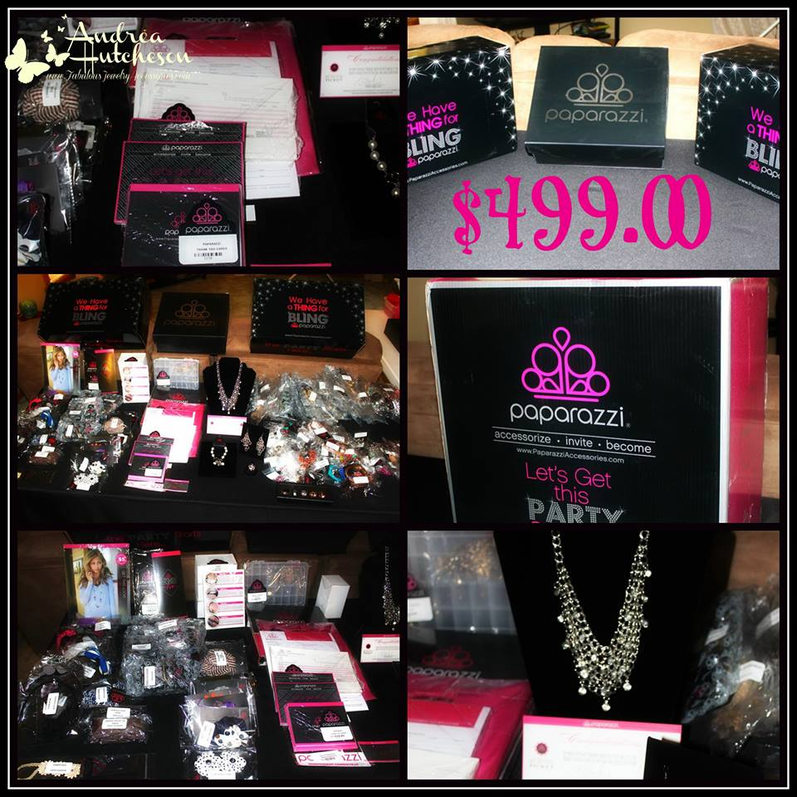
$499 Starter Kit:

Marketing Materials
-Party Invitations
-Pink Sales Bags with Paparazzi Logo
-Display Hooks
-Receipts
-Consultant Applications
-Compensation Plan Brochures
-Jewelry Repair Kit
-The book, Building Your Paparazzi Business
- Paparazzi Business Success Plan

200 Pieces of inventory that are hand-selected to offer your customers a variety of the finest Paparazzi fashions in every color!
Jewelry Displays: Necklace, Ring, and Bracelet.
FREE Convention Ticket worth $200

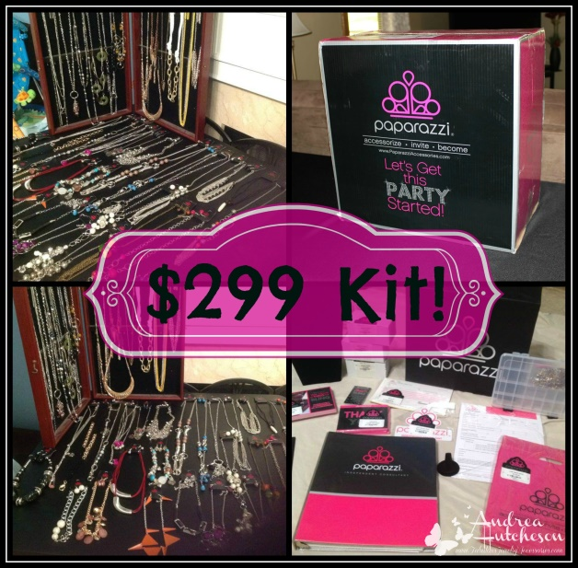

$299 Starter Kit:

Marketing Materials
-Party Invitations
-Pink Sales Bags with Paparazzi Logo
-Display Hooks
-Receipts
-Consultant Applications
-Compensation Plan Brochures
-Jewelry Repair Kit
-The book, Building Your Paparazzi Business
- Paparazzi Business Success Plan

120 Pieces of inventory that are hand-selected to offer your customers a variety of the finest Paparazzi fashions in every color!

Jewelry Displays Necklace and Ring

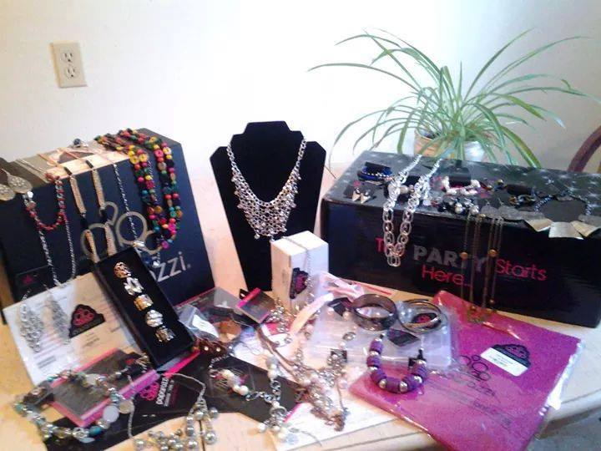

$99 Starter Kit:
Marketing Materials
-Party Invitations
-Pink Sales Bags with Paparazzi Logo
-Display Hooks
-Receipts
-Consultant Applications
-Compensation Plan Brochures
-Jewelry Repair Kit
-The book, Building Your Paparazzi Business
- Paparazzi Business Success Plan

35 Pieces of inventory that are hand-selected to offer your customers a variety of the finest Paparazzi fashions in every color!

Jewelry Display: Necklace

Flexibility to Fit your Life
Schedule parties to fit YOUR schedule, online, open houses, Facebook or basket! You choose!

Our Product Difference
Lead and Nickel FREE

We let the Products do most of the Talking
Our parties have NO presentation. The products sell themselves!

We build on your Existing Experience
We offer training via conference calls, videos, e-mails and one on one.

Repeat Customers
Women love the many, many choices of jewelry and accessories that are available through Paparazzi and they go crazy because everything is only $5.00!!

Residual Income
As a Paparazzi independent consultant, you are able to purchase inventory and sell that inventory at the suggested full retail price. This gives you a 45% commission or profit on all the jewelry sold! In addition to your personal commissions, you will also earn show rebate bonuses, team building bonuses and commissions as you grow your own team of consultants!

Unbeatable Compensation Plan
We earn commission, cash bonuses, product bonuses and leadership overrides plus fabulous trips!

Excellent Earnings
Most consultants start out earning $25-$60 per hour!! What other part-time job allows you such a high pay rate and allows you to have fun while you are “working”?

Free Website
No Monthly Quotas

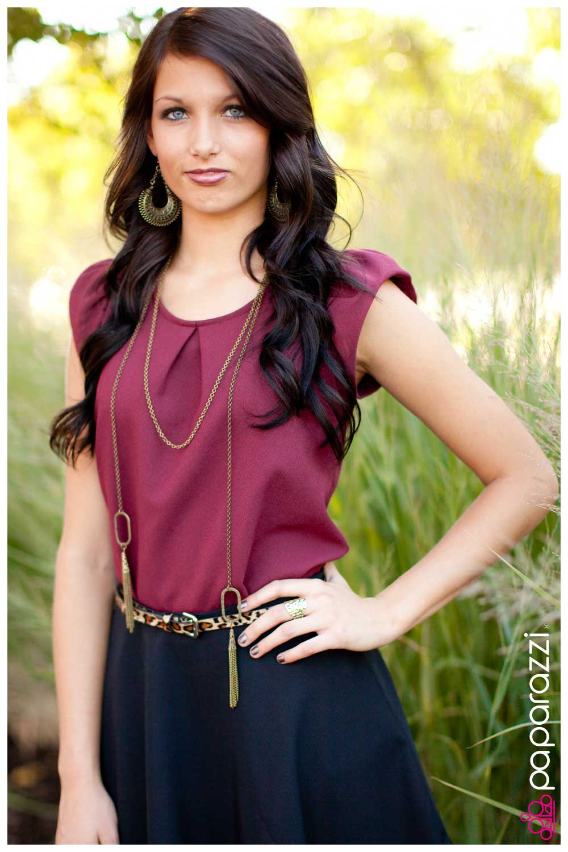

I’m glad to know you’re interested in learning more about the Paparazzi Business Opportunity! It would be my pleasure to go over any questions you might have so Please don’t hesitate to contact me:

Name
Independent Consultant #ID

www.paparazziaccessories.com/ID

Call Phone Number

Email:

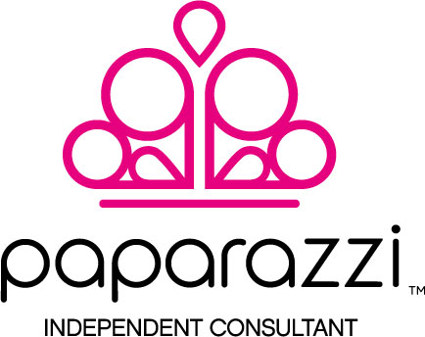
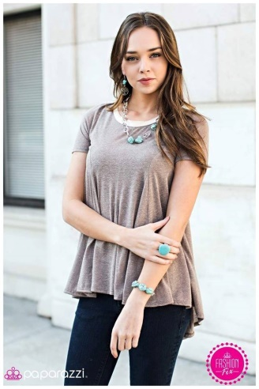
Information Brochure
Accessorize-Invite-Become
Andrea HUtcheson
Independent Consultant #7502

www.paparazziaccessories.com/7502
www.dreasjewelry.com

Cell 765-247-9843
Email: drea.hutch@gmail.com

