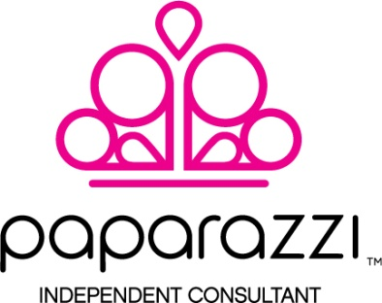

Salon Agreement

The items listed below are on loan only for the use of consultant consignment at:
Store:_____________________________ Date Issued:__________________

The product and samples will remain the property of , Independent Paparazzi Consultant. The store will keep 1 item per 20 sold for hostess incentive.

I, ___________________, understand that any items lost, stolen, broken, or damaged in any way are my responsibility and will be replaced by me, the store owner, of the above mentioned location.

I understand and accept the replacement costs as follows:
- ALL JEWELRY(NECKLACES, EARRINGS, RINGS & BRACELETS), HEADBANDS, AND HAIR CLIPS
$5.00/PIECE and STARLET SHIMMER aka SS (RINGS and EARRINGS) $1.00/PIECE

Item | QTY ISSUED | QTY SOLD
Necklace
Earring
Bracelet
Ring
Hairclip
SS Earring
SS Ring
TOTAL: |  | Value:

Store Signature_____________________________________Date:____________________________
Consultant Signature_____________________________________

Store Name(Please print) ___________________________ Phone:___________________________
Address: __________________________________________________________________________________
CC # for Lost/Damaged Items: _____________________________________________________________
Signature for Lost/Damage Items: __________________________________________________________

STORE COPY

