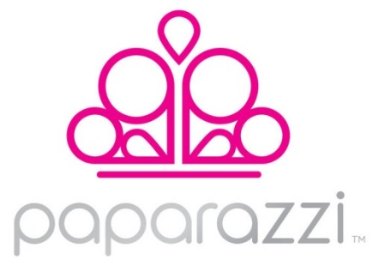

Dear Salon Owner,
My name is Sheila Smith, an Independent Fashion Consultant for Paparazzi Jewelry and Accessories. Paparazzi is a fashion forward jewelry and hair accessory line that is affordable to everyone at only $5.00 plus tax! The merchandise includes necklaces, bracelets, earrings, rings, head bands and hair clips, as well as a children’s line.
Women leave your salon looking and feeling great about themselves, and that is what Paparazzi is all about. Our mission is to assist women in feeling good about themselves at an affordable cost!
I would love to share this opportunity with you. My recommendation is that we set a time within the next two weeks to meet to allow you to personally view the merchandise and discuss how Paparazzi could be an added value to the products/services you currently offer, and can provide you with an increase in revenue with no effort on your part.
Thank you for your consideration. I look forward to speaking with you.
Sincerely,
Sheila Smith
919-427-1641
paparazzified@gmail.com
www.facebook.com/MyBlingRoom
www.paparazziaccessories.com/11637
