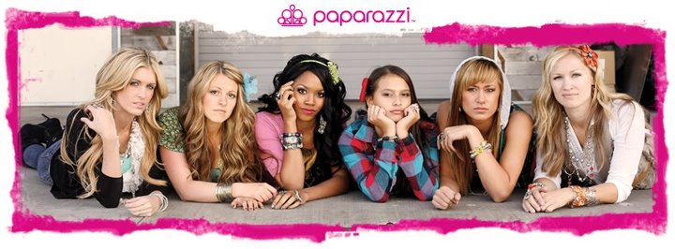

Here is some information about what to do or expect for your party!
Invitations:
~ Plan on 1/3 of the people you invite to actually come. So invite a ton of people!
~ Send out invitations about a week prior to the party date.
~ Make a Facebook event and/or email guests to come
~ The day before (and the day of the party) email, remind on Facebook and/or call your guests to remind
them of your party!
~ The day of the party, text your friends a quick reminder!

Your Rewards!
Here are the hostess incentives that I use:
~ One free items for hosting the party
~ One free item for every $50 sold
~ One free item if your party reaches $250 in sales
~ One free item for every party booked (item will be received at THEIR party)
My Display:
~ I have several different displays options we can use. Depending on the space you have to host
the party, we can simplify the display. Just let me know how large or small you would like it!
~ You can offer refreshments to your guests. But keep it simple. Usually people just come, shop,
and then leave. I say this because, I don’t want you to spend lots of money and have lots left over.
That’s frustrating! You don’t have to have any if you choose.
~ I accept cash, checks and credit cards.
~ I will try and be there about 1 hour before party time to set up.

If you have any questions, please call or text me at 919-427-1641
Thanks again for hosting a party! I can't wait!
Sheila Smith ~ Paparazzi Independent Consultant #11637
paparazzified@gmail.com * www.Facebook.com/MyBlingRoom * www.MyBlingRoom.com

Your Event will be held on:

Date:

Time:

